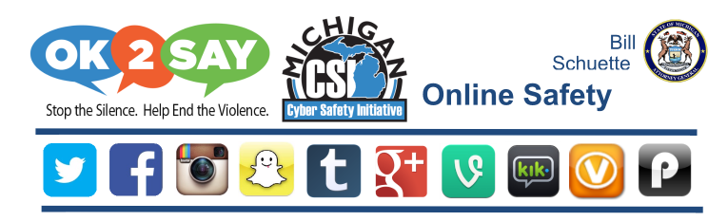

The following links will connect you with a broad spectrum of resources assembled by Michigan’s Department of the Attorney General.

[CSI Online resources](https://drive.google.com/file/d/0B0OlVbD5VCSnMGJtVGtxSzM4OXM/view?usp=sharing)

[Sites & Apps, Warning signs, Safety tips](https://drive.google.com/file/d/0B0OlVbD5VCSnWS11VDF1Rm9aamM/view?usp=sharing)

[Online Safety Contract](https://drive.google.com/file/d/0B0OlVbD5VCSnV09wZHQ3N1E0RU0/view?usp=sharing)

[Social Networking Discussion Questions & Action Plan](https://drive.google.com/file/d/0B0OlVbD5VCSnSC1oNUxqTG9hSlk/view?usp=sharing)

[Instagram Resources](https://drive.google.com/a/gpschools.com/file/d/0B0OlVbD5VCSnYm1CYWh6bDVINHc/view?usp=sharing)

[Twitter Resources](https://drive.google.com/file/d/0B0OlVbD5VCSnSzZ3Zmh5UnJMUGs/view?usp=sharing)

[Facebook Resources](https://drive.google.com/a/gpschools.com/file/d/0B0OlVbD5VCSnYmVhc0NvZmZoSXM/view?usp=sharing)